Computer hardware

What is a computer?

INPUT

PROCESS

OUTPUT

STORAGE

A computer is a programmable machine. The two principal characteristics of a computer are:

1. It responds to a specific set of instructions in a well-defined manner
2. It can execute a pre-recorded list of instructions (a program)

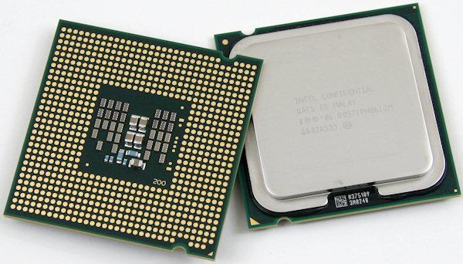Central processing unit (CPU)

The Central Processing unit (CPU) takes input data processes it then out puts it.

The 2 biggest CPU manufacturers are Intel and AMD.

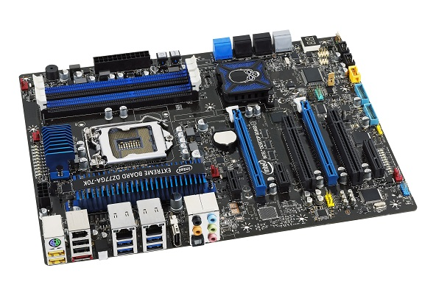Motherboard (Mobo)

The Motherboard is a circuit board that contains the main computers components. All the other part of the computer feed of the mother board.

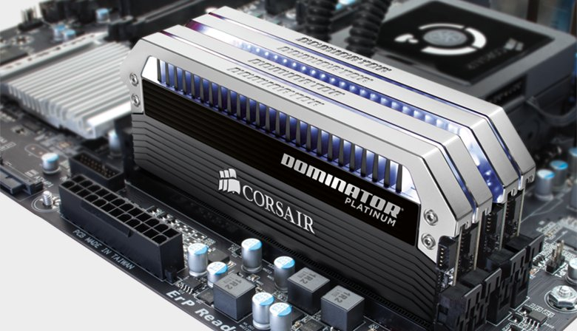Random access memory (RAM)

Random access memory (RAM) is a temporary storage unit that stores data as you use it. The more ram you have the more programs you can have running.

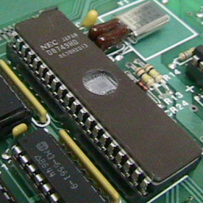Read only memory (ROM)

Read only memory (ROM) is a small storage unit that permanently stores data. ROM can store data like the boot up files need for the computer.

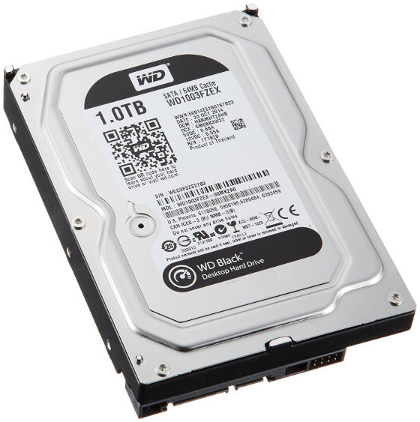Hard drive (HHD)

Hard drive (HHD) is the computers main storage unit. The HHD stores all your files programs and the entire Operating System (OS) it also stores any partitions and other OS’s. you can also get a SSD that is a another type of storage.

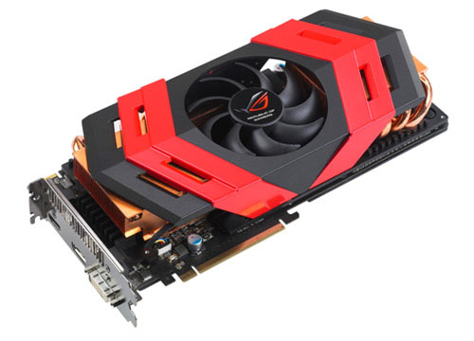Video card (graphics card)

The graphics card is designed to reduce the load on the CPU by processing the graphics for it. A graphics card is used for processing programs graphics. Manly need for games.

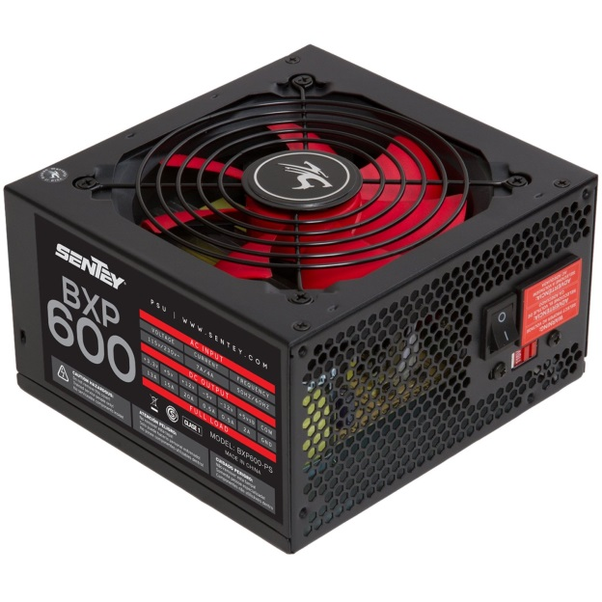Power supply

The Power Supply gives

Sound card

Network card

Notes on video Inside your computer

* mouse is simple machine and a system for detecting motion and distance
* mouse sends message to computer about location
* CPU processes the message. It provides a way for the computer to interact with it’s environment

https://www.youtube.com/watch?v=AkFi90lZmXA